Hi Phong,

here are the 3 new projects by the order i need them:

1 - approve profiles manually

2 - add option to enter coupon/code to have a discount when or use a membership plan for employers:

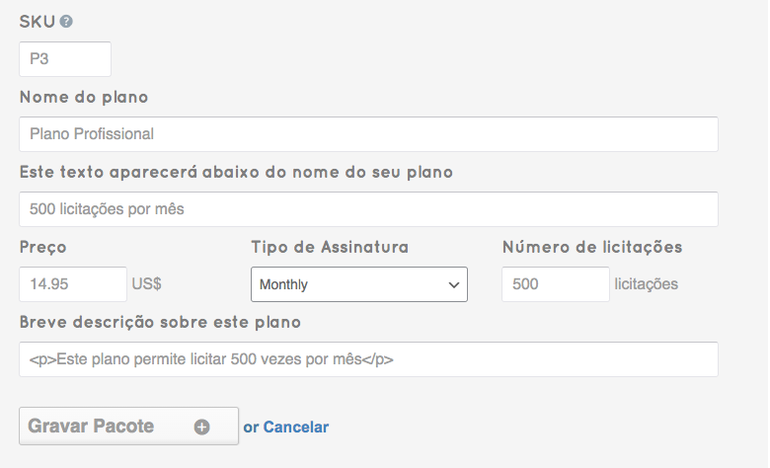

a new field added for coupon/code so a certain employee enters the amount it has a % discount

Something like this, i am open to new ideas. I need a way to offer discount prices/offers to specific employees.

3 - Creation of an ID Validation/Verification page that a freelancer can validate his or her ID, adding the full name, date of birth, identification number, and upload 2 photos, one with the ID and the other with the person holding the ID. This validation has to be approved by the admin and when it is approved a symbol will appear next to the profile. The link to this validation page should only be visible in the menu if the  freelancer is logged in.

Make  a separate page called ID validation an put the link after "My credit":

in the end it has a button just saying save. After it is saved, the admin receives a notification to approve, if approved the profile of the freelancer gets a symbol like this:

the symbol is attached to this email.

if not approved, the freelancers gets an email that was not approved and he can resubmit another. The email message should be editable from here:

This is what is needed now.

Will wait for your feedback.

Thank you